RESOLUTION NO.__________

RE: CERTIFICATE OF APPROPRIATENESS UNDER THE
PROVISIONS OF THE ACT OF THE PENNSYLVANIA
LEGISLATURE 1961, JUNE 13, P.L. 282 (53
SECTION 8004) AND BETHLEHEM ORDINANCE NO.
3952 AS AMENDED.

WHEREAS, it is proposed to install a blade sign and window signs at 333 S. New St.

NOW, THEREFORE, BE IT RESOLVED by the Council of the City of Bethlehem that a Certificate of Appropriateness is hereby granted for the work.

Sponsored by: (s)

(s)

ADOPTED BY COUNCIL THIS DAY OF

(s)
President of Council

ATTEST:

(s)
City Clerk

HISTORIC CONSERVATION COMMISSION

CASE # 436 – It is proposed to install a blade sign and window signs at 333 S. New St.
OWNER/APPLICANT: Wind Drift R.E./ Full of Crepe, LLC

The Commission upon motion by Mr. Roeder seconded by Mr. Cornish adopted the proposal that City Council issue a Certificate of Appropriateness for the proposed work described herein:

- The proposal to install a blade sign and window signs at 333 S. New St. was presented by Ashley Caldwell of Full of Crepe, LLC.

- The proposed window appliqué will be a circular logo, 24” in diameter, applied to the front facing display window. The logo will be a red circle outlined in black with white letters outlined in black reading “Full of Crepe” with “sweet & savory” in black lettering.

- The proposed door appliqué will be the same circular logo 12” in diameter applied to the upper portion of the glass front door with the hours in vinyl on the lower portion.

- The proposed blade sign will be 24” in diameter, hang from a traditional style black wrought iron bracket, and affixed to the mortar joints directly above the storefront cornice between the two storefronts.

- The proposed motion was unanimously approved.

CU: cu

By: 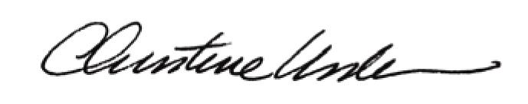

Date of Meeting: December 17, 2012 Title: Historic Officer

